## horizontal line



Electoral Bond Data Analysis

Sayan Banerjee

RB-Web SkillUp

Python-DS

# Project Overview:

The "Political Donation Analysis and Corporate Giving Fraud Detection" project aims to analyze two primary datasets. The first dataset entails information regarding political parties, the dates they receive donations, and the respective amounts. The second dataset comprises details of companies, their donation dates, and the amounts contributed. The objective is to create insights by identifying the top 20 donating companies and examining their financial performance, specifically revenue, profit, or loss. Additionally, the project seeks to detect potential instances of fraud by comparing company profits with their donation amounts.

# Project Goals:

## 1. Data Analysis:

- Analyze the political donation dataset to identify trends, such as donation amounts received by each party over time.

- Explore the corporate donation dataset to understand which companies are contributing, how much, and when.

## 2. Top Donating Companies Identification:

- Determine the top 20 companies based on their donation amounts.

- Rank these companies to understand their significance in terms of contributions.

## 3. Financial Performance Evaluation:

- Assess the revenue, profit, or loss of the identified top donating companies.

- Investigate whether the profit exceeds, equals, or falls below the donation amount for each company.

## 4. Fraud Detection:

- Establish criteria to flag potential instances of fraud by comparing profits with donation amounts.

- Classify companies as potentially fraudulent or not based on the outcome of the comparison.

## 5. Insights Generation:

- Generate actionable insights regarding the relationship between corporate donations, financial performance, and potential fraudulent behavior.

- Provide recommendations for further investigation or corrective action based on the findings.

# Introduction:

Our project proposal focuses on analyzing political donation data and detecting potential instances of fraud related to corporate giving. Political funding transparency and integrity are crucial for ensuring fair democratic processes, while accurate financial reporting is essential for maintaining trust in corporate entities. By combining data analysis techniques with fraud detection methodologies, we aim to shed light on the relationship between political donations, corporate contributions, and financial performance.

# Objectives:

* Analyze two primary datasets: political party donations and corporate contributions.
* Identify the top 20 donating companies based on their contribution amounts.
* Evaluate the financial performance (revenue, profit, or loss) of these top donating companies.
* Compare company profits with donation amounts to detect potential instances of fraud.
* Generate actionable insights and recommendations based on the findings.

# Methodology:

## Data Collection:

Gather political donation data, including the recipient parties, donation dates, and amounts. Acquire corporate giving data, comprising donor companies, donation dates, and amounts.

## Data Analysis:

Employ statistical and visualization techniques to analyze donation trends, identify top donating companies, and evaluate financial performance.

## Fraud Detection:

Develop criteria to compare company profits with donation amounts and flag potential instances of fraud.

## Insights Generation:

Derive insights from the analysis and fraud detection results to inform decision-making and future actions.

# Workflow:

# Data Collection:

The Data was collected from . The Data was uploaded by SBI.

# Data Description:

The data set that stored the information of donation that give to political parties, name is EncashmentData.csv

### Column:

1. Date of Encashment: Date of the donation to the particular Political Party.
2. Name of the Political Party:
3. Denomination: the value of Donation at a time

The data set that store the information about donation of companies , name is PurchaseData.csv

### Column:

1. Date of Purchase: Date of the donation of the particular company.
2. Purchaser Name : Name of the Company
3. Denomination: the value of Donation at a time

The data set of top 20 companies those are donate maximum rupees, name is TOp_Company.csv

### Column:

1. Purchaser Name : Name of the Company
2. CIN: A company's Corporate Identification Number (CIN)
3. Date of Registration: the date when the company is legally recognized
4. Revenue: the total amount of money it brings in from its operations over a set period of time
5. Profit/ Loss: The amount of profit or loss of the company last year.
6. Ebitda: is a metric used to measure a company's profitability
7. Denomination: the value of Donation at a time
8. Conflict: The company is doing fraud or not.

# 

# Data Analysis:

## Analysis the EncashmentData

### Top 10 Political Parties According to Denomination

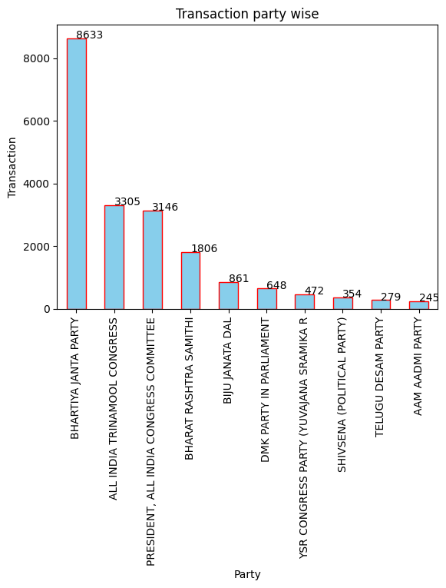

### 

### Top 3 political parties:

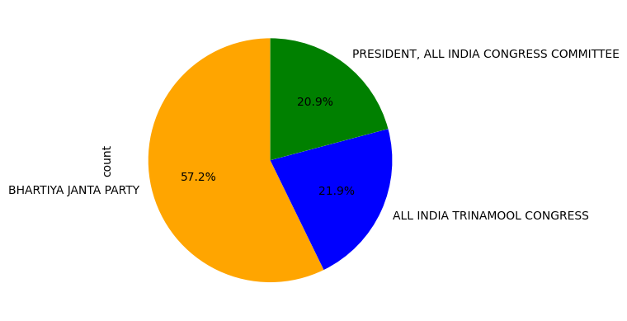

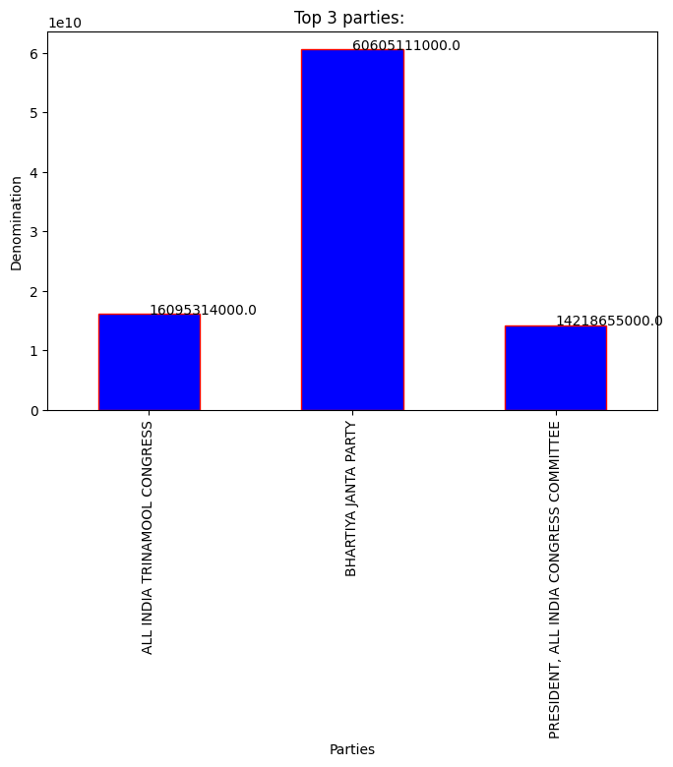

### How many days the top 3 company get more than 1 lakh and 10 lack donation

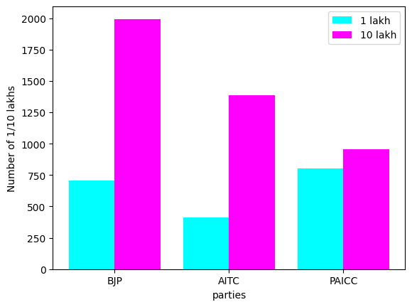

1. Year Wise Denomination: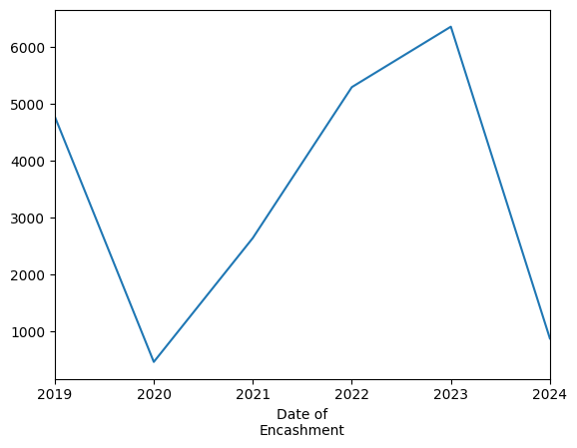

## B. Analysis the PurchaseData

### Year Wise Denomination:

### Top 10 companies respective of denomintaion.

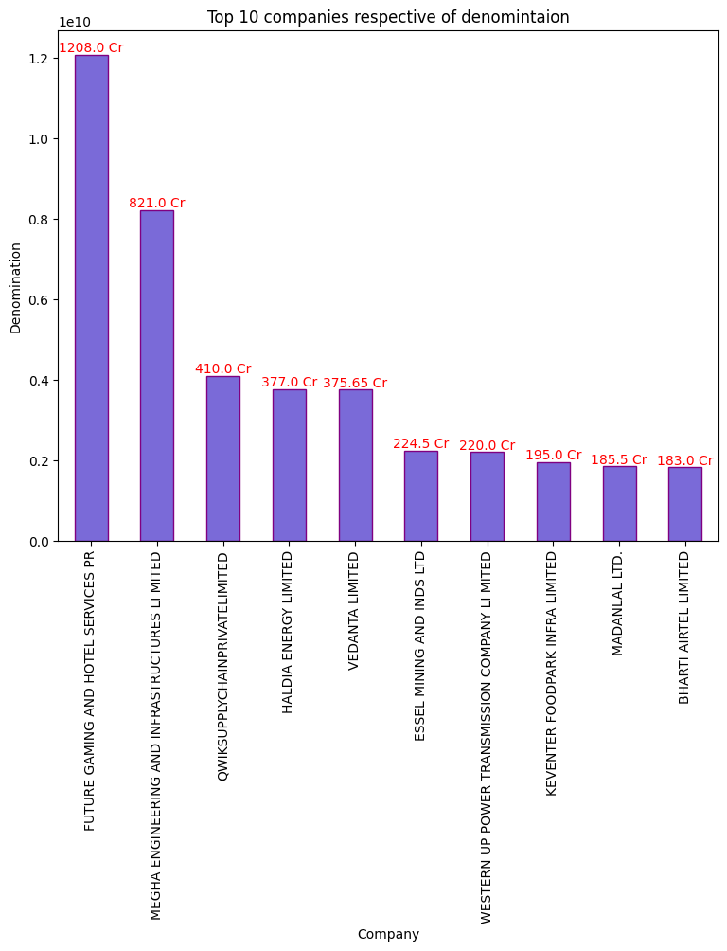

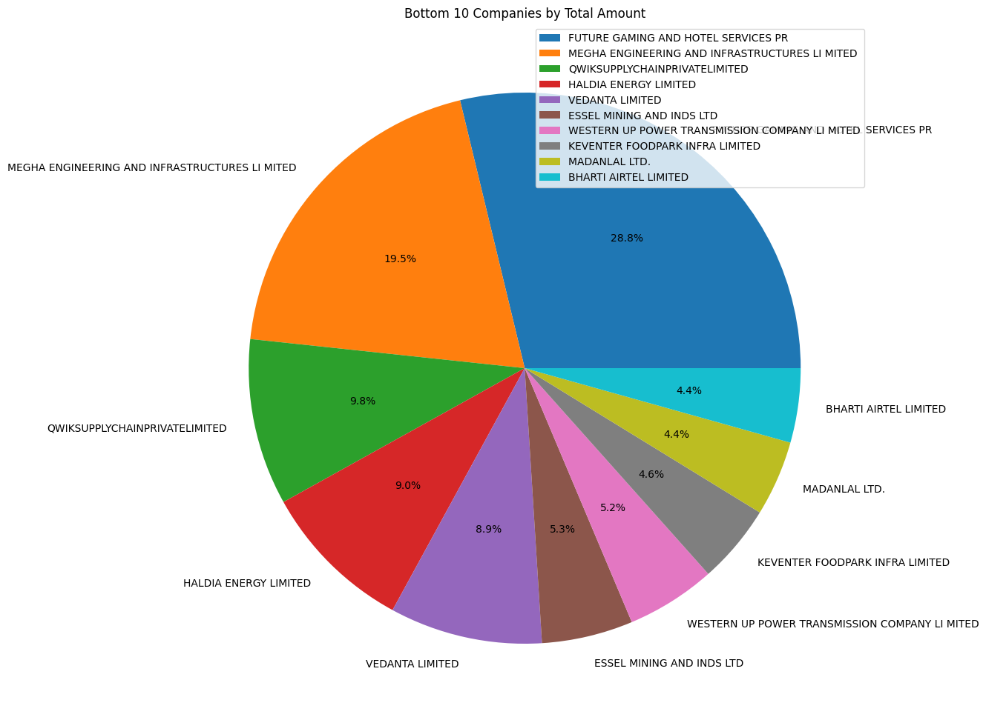

### 

### 

### 

### 

### Top 10 companies respective of denomination.

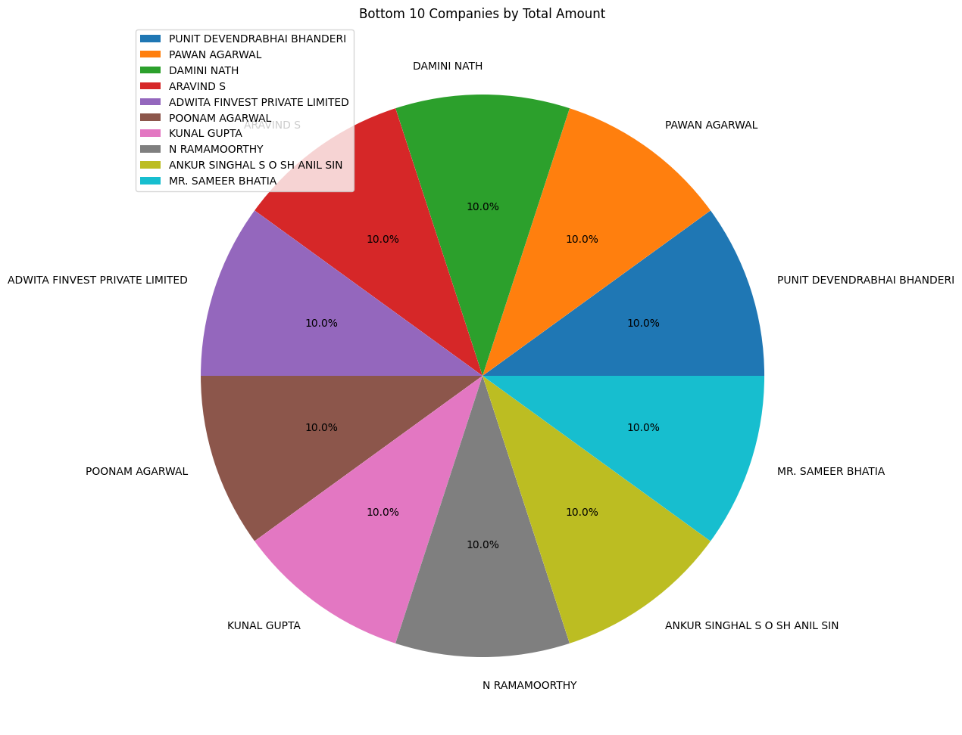

## **Analysis The Top 20 company data:**

Top 5 :



# Conclusion:

In conclusion, the analysis of electoral bond data provides valuable insights into the dynamics of political financing in India. While electoral bonds were introduced with the intention of promoting transparency and accountability, our examination reveals certain challenges and concerns.

The data highlights significant gaps in transparency, as the anonymity of donors raises questions about the influence of undisclosed contributions on political decisions. Moreover, the concentration of donations from certain sectors or entities underscores the potential for unequal influence in the democratic process.

Moving forward, it is imperative to address these issues and strengthen the electoral bond system to uphold the principles of fairness, integrity, and public trust in democracy. Reforms aimed at enhancing transparency, accountability, and equal access to political funding are essential for safeguarding the integrity of the electoral process and promoting a more inclusive and democratic society.